William O’Brien
Geogebra Lesson: Polygons and Pi
Grades: 9-12
- Open the Geogebra Program on your computers.
- Start by going to Options then Labeling then No New Objects on your navigation bar.
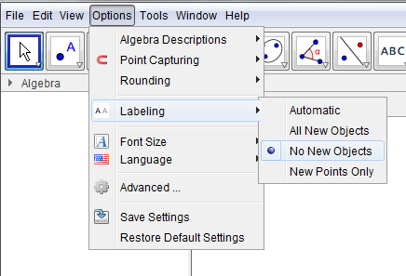
- Then under the Graphics tab select the grid that says “Show or Hide Axis”
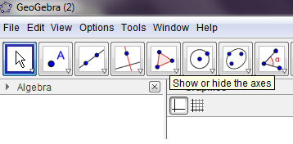
- Create your center and radius for your circle by plugging into the Input Bar the following points as shown below:

A=(0,0) then click ENTER
B=(1,0) then click ENTER

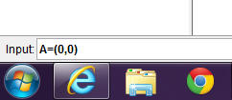

**Note: When you create your first parenthesis for point A it will appear as this. --> A=()

- Label first point, Point A, by double clicking on the point, select Object Properties, then click Show Label box. Repeat this process for Point B.
- Now, create a circle by clicking the down arrow on the circle button as shown below, selecting Circle with Center through Point.
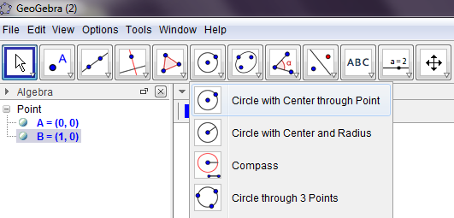
- Start by dragging your cursor to your first point (A), clicking on it, then dragging the cursor to the second point (B) and clicking on that point, forming your circle.

**Note: Your circle will start forming when you click on your first point A.

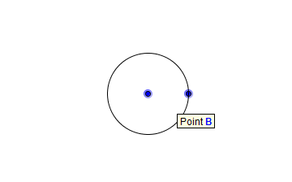

- Click on the 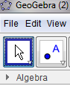 (Move Button), then click on the white area outside of your circle. Use Ctrl+Shift+(+ or -) to Zoom In and Out on your circle figure. Use the directional arrows <- and -> to center your circle in the middle of your screen as shown below:
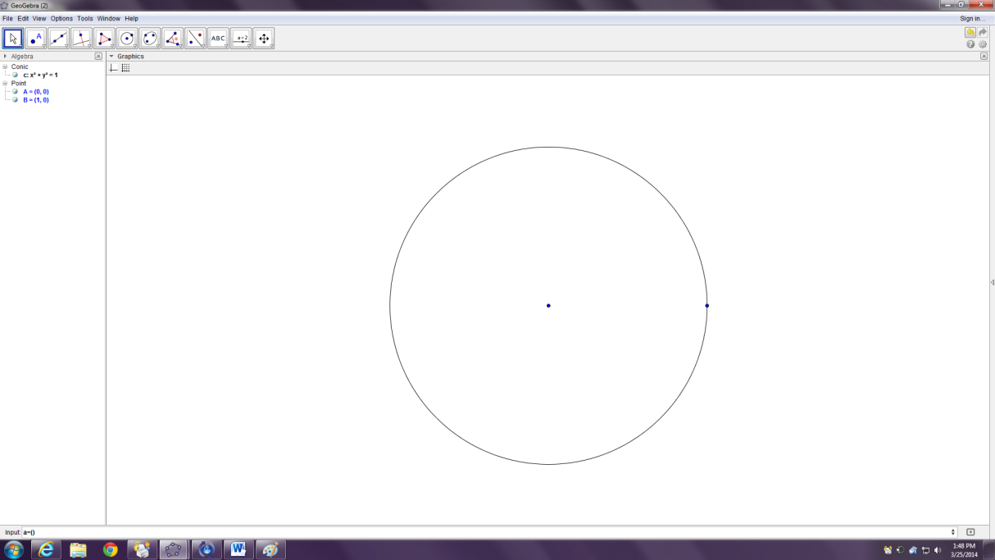

- Now, create a slider by selecting the slider button shown below:

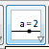

Click anywhere in the white area and a slider window will open.
- Choose Integer.
- In the Name bar write the letter n
- Change the Min: 1 and Max: 50
- Then Press Apply
Drag your slider to a visible white area on your screen.

- Now, we are going to Rotate Point B. Click the down arrow on the Rotate/Reflect Button located to the left of the ABC button. Select Rotate around Point as shown below:
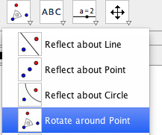
Then Click on Point B then on Point A and a third point, Point B’, will form on your circle.
Click on the Move Button from Step #8 and move your value of n on your slider until you can see Point B’ separate from Point B on your circle.
- Click the down arrow on the Polygon Button located to the left of the Circle button. Select Regular Polygon as shown below:
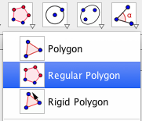
A cursor will appear, then click on Point B then click on Point B’ and a window will appear. When the window appears input “n” in the points bar and press OK.

- Click on the move button, and then drag the slider from left to right and notice that with n amount of points/vertices a regular polygon is made with that many number of points/vertices. Make a regular polygon with at least n = 3 points/vertices.

- Click on the ABC Button located to the left of the slider button, and a cursor will appear. Click on a white area outside of your new Regular Polygon and Circle objects.

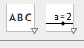

In the Edit box type in Area of a Polygon= then select the Objects button and scroll down and choose poly1. Then press OK.
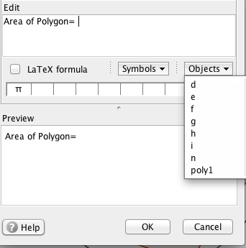

- Go to Options then Rounding then 5 Decimal Places. Then change the n value on the slider and try to pick up on how the Area of the Polygon changes as we look at the questions on the following page.

Questions for Discovering Relationships Geogebra Activity:
- List some of the patterns you notice when you change the slider (n-values)??
_____________________________________________________________________
_____________________________________________________________________
_____________________________________________________________________
- What changes do you see occur as the n-values increase to create a pentaconagon, 50 points/vertices?
_____________________________________________________________________
_____________________________________________________________________
- What would be the area of the circle figure in our worksheet if we know that the radius is equal to 1?
_____________________________________________________________________
_____________________________________________________________________
- What can we notice about the Area of the Polygon we created in this Geogebra Worksheet?
_____________________________________________________________________
_____________________________________________________________________
- How is the Area of the Polygon and the Area of the Circle related? What would you think the Area of the Polygon would be if the slider went up to 100? 500? 2000?
_____________________________________________________________________
_____________________________________________________________________
_____________________________________________________________________
- How many vertices or points does our polygon need to have in order for it to have the same area as the circle?
_____________________________________________________________________
_____________________________________________________________________
_____________________________________________________________________

Sources for Geogebra Activity:
YouTube Video: Polygons and Pi (Week 2, Part 9)
Link: https://www.youtube.com/watch?v=V6Gl1dx8V2U

Conclusion:
I would teach this topic of inscribing a regular polygon with a circle during a inscribing lesson in a Geometry classroom in 9-12th grade classroom. Students would use Geogebra and the technology provided to discover the relationship between the Area of a Circle with radius=1 and the inscribed Area of a Polygon. Discovering the relationship of Pi being the circumference divided by the diameter would be a lesson that can be demonstrated afterwards with this circle on this Geogebra program through the use of sliders as well.

